For graphing a given **ellipse** we need seven points on the graph those include the center (0,0), **vertices** (0,\pm \textcolor{primary}{a}), two **co-vertices** (\pm \textcolor{secondary}{b},0), and two **foci** (0,\pm \textcolor{tertiary}{c}).

As we know that the equation of a **Vertical ellipse** is given by:

\frac{x^{2}}{\textcolor{secondary}{b}^{2}}+\frac{y^{2}}{\textcolor{primary}{a}^{2}}=1

As given equation of a ellipse is given by:

\frac{x^{2}}{\textcolor{secondary}{3}^{2}}+\frac{y^{2}}{\textcolor{primary}{6}^{2}}=1

For finding **foci** we have:

\textcolor{tertiary}{c}=\sqrt{\textcolor{primary}{a}^{2}-\textcolor{secondary}{b}^{2}}

For finding **foci** we have:

\textcolor{tertiary}{c}=\sqrt{\textcolor{primary}{a}^{2}-\textcolor{secondary}{b}^{2}}

So, we have center (0,0), vertices (0,\pm \textcolor{primary}{6}), two co-vertices (\pm \textcolor{secondary}{3},0), and two foci (0,\pm \textcolor{tertiary}{5}).

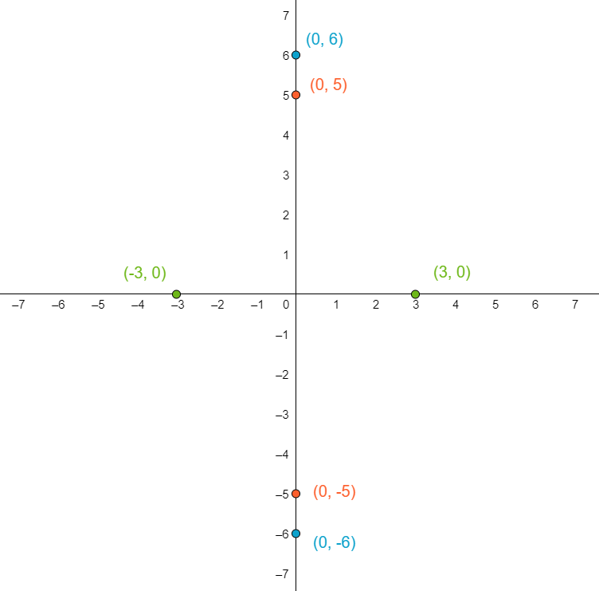

Now using the graph, label the x and the y axis and label points on the graph.

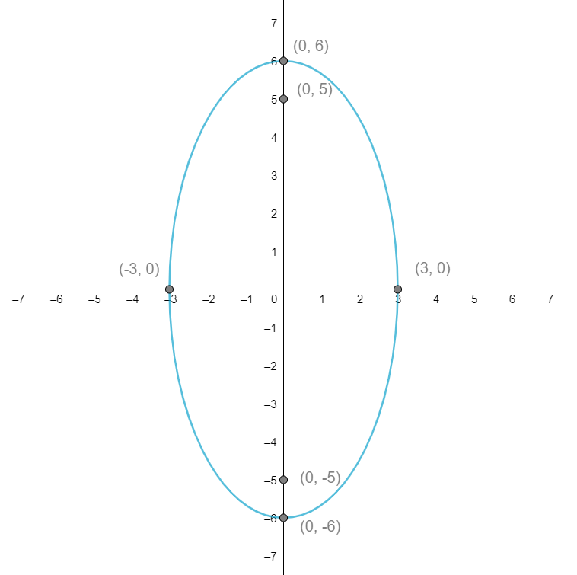

Draw ellipse.

Calculating the center (0,0), vertices (0,\pm \textcolor{primary}{6}), two co-vertices (\pm \textcolor{secondary}{3},0), and two foci (0,\pm \textcolor{tertiary}{5}) to plot graph.